**NAME: P.NITYASREE**

**REGNO: 17MIS1007**

**COURSE: INFORMATION SECURITY MANAGEMENT[CSE 3502]**

**FACULTY: ANUSHA**

**LAB EXERCISE-4**

**STEPS:**

1. **Configure the both routers as WIC-2t**

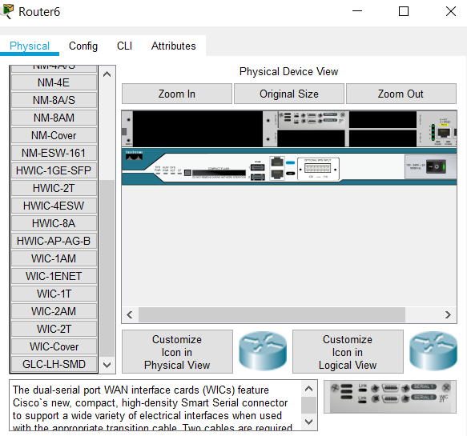

1. **Give connections between routers, pc’s, server, and switches**
2. **Configure the pc0 with ip address 192.168.1.1**

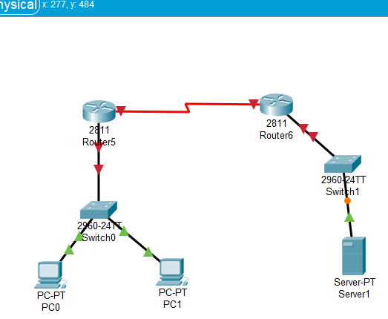

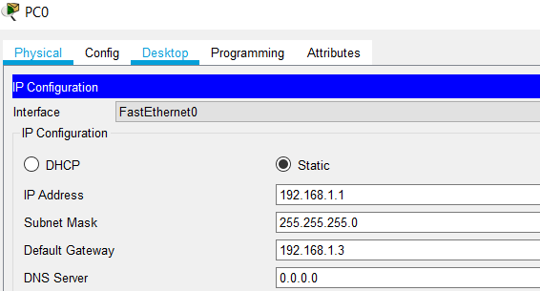

1. **Configure the pc1 with ip address 192.168.1.2**

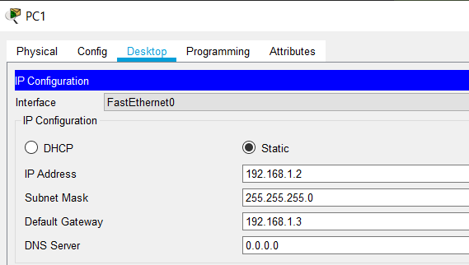

1. **Configure and interface the router with FastEthernet0/0 and also interface the serial**
2. **And add ip address 1.0.0.1 and subnet address as 255.0.0.0**

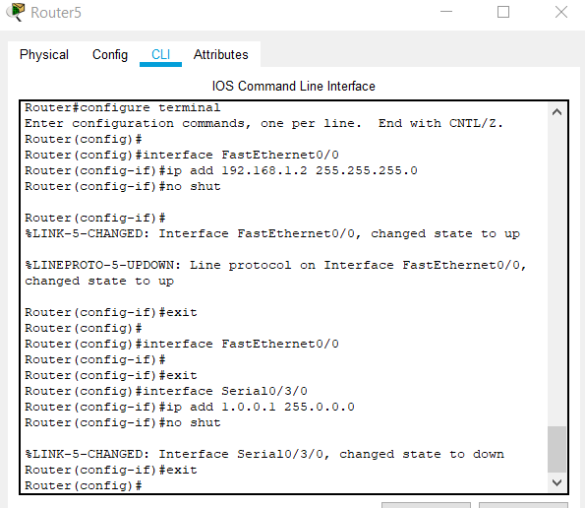

1. **Configure and interface the router with FastEthernet0/0 and also interface the serial**
2. **And add ip address 1.0.0.2 and subnet address as 255.0.0.0**

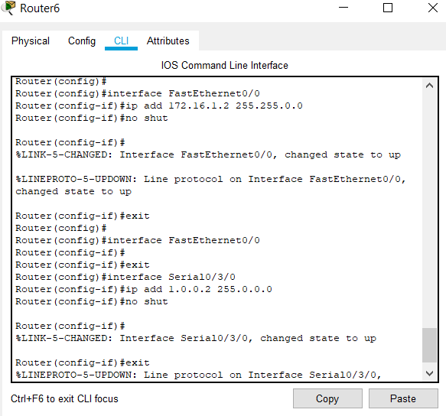

1. **NAT configuration for both the routers by the following commands**
2. **And get NAT inside, inside local, outside local, and outside**

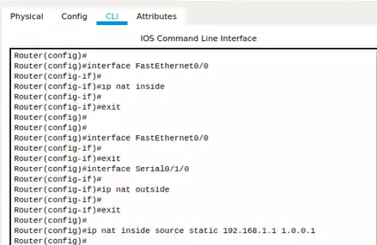

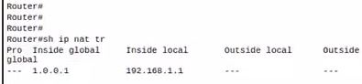

**For second router:**

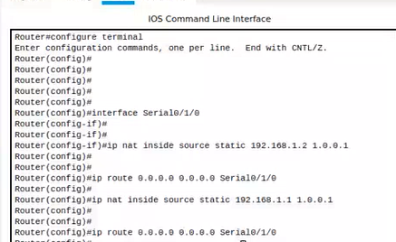

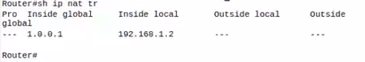

**AFTER SUCCESSFUL CONNECTONS:**

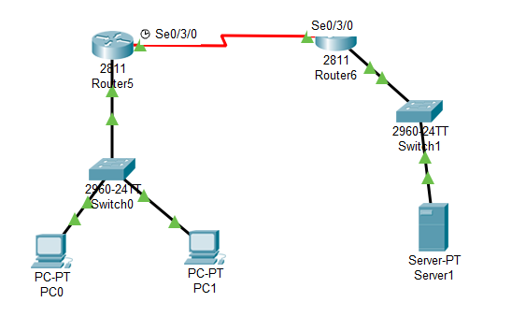

**MESSAGE TRANSFER:**



